pXRF analysis

Uine Kailamäki

04/01/2021

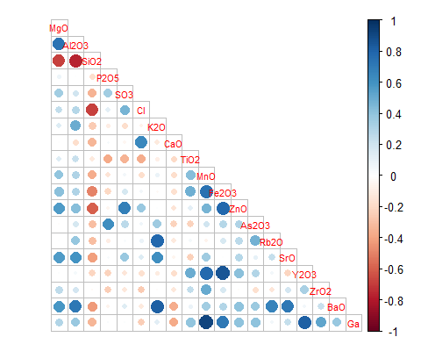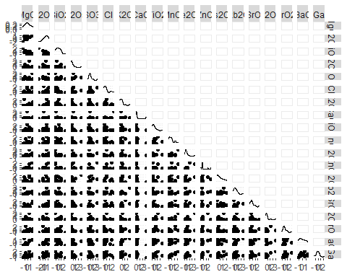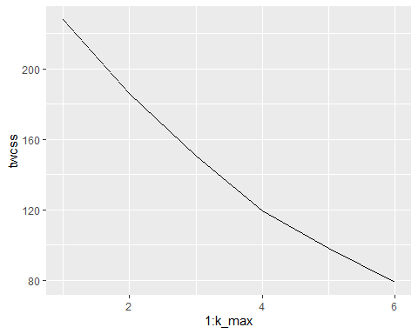

## Importance of components:  
## PC1 PC2 PC3 PC4 PC5 PC6 PC7  
## Standard deviation 2.4331 1.9011 1.6155 1.4016 1.24956 1.08327 0.94306  
## Proportion of Variance 0.3116 0.1902 0.1373 0.1034 0.08218 0.06176 0.04681  
## Cumulative Proportion 0.3116 0.5018 0.6392 0.7426 0.82473 0.88649 0.93330  
## PC8 PC9 PC10 PC11 PC12 PC13  
## Standard deviation 0.72080 0.59170 0.56800 0.2349 0.14099 3.143e-16  
## Proportion of Variance 0.02734 0.01843 0.01698 0.0029 0.00105 0.000e+00  
## Cumulative Proportion 0.96064 0.97907 0.99605 0.9990 1.00000 1.000e+00

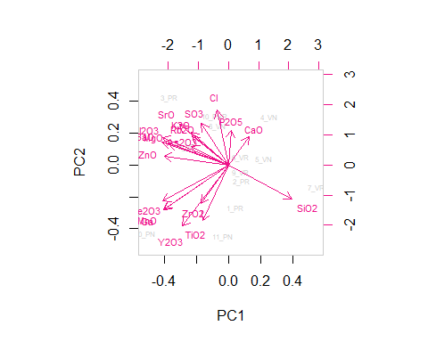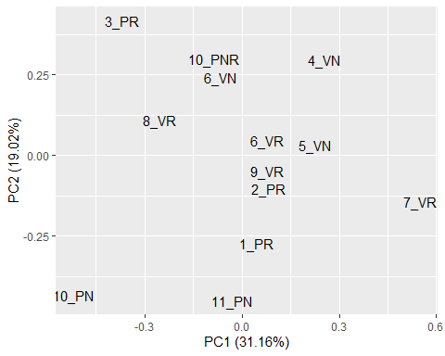

## [1] 0.4773373

